**Min Stack**

Design a stack that supports push, pop, top, and retrieving the minimum element in constant time.

Implement the MinStack class:

* MinStack() initializes the stack object.
* void push(int val) pushes the element val onto the stack.
* void pop() removes the element on the top of the stack.
* int top() gets the top element of the stack.
* int getMin() retrieves the minimum element in the stack.

You must implement a solution with O(1) time complexity for each function.

**Example 1:**

**Input**

["MinStack","push","push","push","getMin","pop","top","getMin"]

[[],[-2],[0],[-3],[],[],[],[]]

**Output**

[null,null,null,null,-3,null,0,-2]

**Explanation**

MinStack minStack = new MinStack();

minStack.push(-2);

minStack.push(0);

minStack.push(-3);

minStack.getMin(); // return -3

minStack.pop();

minStack.top(); // return 0

minStack.getMin(); // return -2

**Constraints:**

* -231 <= val <= 231 - 1
* Methods pop, top and getMin operations will always be called on **non-empty** stacks.
* At most 3 * 104 calls will be made to push, pop, top, and getMin.

Consider each node in the stack having a minimum value. (Credits to @aakarshmadhavan)

var MinStack = function() {

};

/**

* @param {number} val

* @return {void}

*/

MinStack.prototype.push = function(val) {

};

/**

* @return {void}

*/

MinStack.prototype.pop = function() {

};

/**

* @return {number}

*/

MinStack.prototype.top = function() {

};

/**

* @return {number}

*/

MinStack.prototype.getMin = function() {

};

/**

* Your MinStack object will be instantiated and called as such:

* var obj = new MinStack()

* obj.push(val)

* obj.pop()

* var param_3 = obj.top()

* var param_4 = obj.getMin()

*/

Solution

Overview

Firstly, don't feel bad if you find this question a bit tricky! While it's one of the easier data structure design questions, it's still one of Leetcode's more difficult "easy" questions, requiring some clever observations and problem-solving techniques.

Now, here's a few things to keep in mind before we get started.

* **Make sure that you read the question carefully**. The getMin(...) operation only needs to return the value of the minimum, it *does not remove items from the MinStack*.
* We're told that **all the MinStack operations must run in constant time**, i.e. O(1)*O*(1) time. For this reason, we can immediately rule out the use of a Binary Search Tree or Heap. While these data structures are often great for keeping track of a minimum, their core operations (find, add, and remove) are O(\log \, n)*O*(log*n*), which isn't good enough here! We will need to explore better ways.
* Some people have mentioned on the discussion forums that **the question doesn't say what to do in invalid cases**. For example, what if you are told to pop(...), getMin(...), or top(...) while there are no values on your MinStack? Because the question doesn't say, here on Leetcode that means **you can safely assume the test cases will always be *valid***. In a real interview though, *you should always ask the interviewer before making assumptions*. They will probably either say you can assume these cases won't happen, or that you should return -1 or throw an exception if they do.
* **Finally, there is the issue of whether or not it is "fair" to use a built-in Stack** data structure as the basis of your MinStack implementation, or whether you should only use Lists or even Arrays. Because I don't think there is much advantage to using a built-in Stack here—you still need to figure out how to use it to achieve the minimum functionality—this solution article uses Stack's. *Implementing an underlying Stack yourself shouldn't be too difficult, and is ideally something you already know how to do if you're working on this question.*

**Suggestion for further study**: Once you've read through this guide and understood how to implement the MinStack class, have a go at writing a MaxStack class on your own to test your understanding! Don't simply copy-paste the MinStack code and attempt to modify it into the new role, instead write the MaxStack code *without looking at the MinStack code again*.

Approach 1: Stack of Value/ Minimum Pairs

**Intuition**

An **invariant** is something that is always true or consistent. You should always be on the lookout for useful invariants when problem-solving in math and computer science.

Recall that with a Stack, we only ever add (push) and remove (pop) numbers from the *top*. Therefore, an important **invariant** of a Stack is that when a new number, which we'll call x, is placed on a Stack, the numbers below it *will not change* for as long as number x remains on the Stack. Numbers could come and go *above* x for the duration of x's presence, but *never* below.

So, whenever number x **is** the *top of the Stack*, the minimum will always be the same, as it's simply the minimum out of x and all the numbers *below* it.

Therefore, in addition to putting a number on an underlying Stack inside our MinStack, we could also put its corresponding minimum value alongside it. Then whenever that particular number is at the top of the underlying Stack, the getTop(...) operation of MinStack is as simple as retrieving its corresponding minimum value.

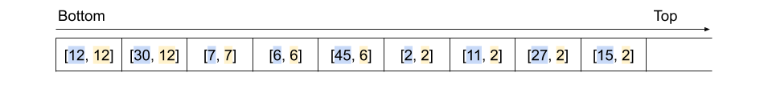

So, how can we actually determine what the corresponding minimum for our new number is? (in (O(1)(*O*(1) time). Have a look at the diagram above. All the minimum values are equal to either the minimum value immediately before, or the actual stack value alongside.

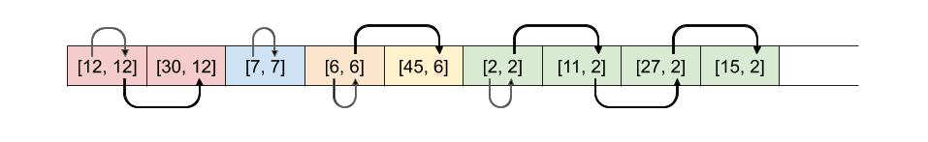

Therefore, when we put a new number on the underlying Stack, we need to decide whether the minimum at that point is the new number itself, or whether it's the minimum before. It makes sense that it would always be the smallest of these two values.

Here is an animation showing the entire algorithm described above.

**Algorithm**

Note for Python: Recall that index -1 refers to the *last* item in in a list. i.e. self.stack[-1] in Python is equivalent to stack.peek() in Java and other languages.

// written by @jamesernator (James Browning)

function last(arr) {

return arr[arr.length - 1];

}

class MinStack {

_stack = [];

push(x) {

// If the stack is empty, then the min value

// must just be the first value we add

if (this._stack.length === 0) {

this._stack.push([x, x]);

return;

}

const currentMin = last(this._stack)[1];

this._stack.push([x, Math.min(currentMin, x)]);

}

pop() {

this._stack.pop();

}

top() {

return last(this._stack)[0];

}

getMin() {

return last(this._stack)[1];

}

}

**Complexity Analysis**

Let n*n* be the total number of operations performed.

* Time Complexity : O(1)*O*(1) for all operations.

push(...): Checking the top of a Stack, comparing numbers, and pushing to the top of a Stack (or adding to the *end* of an Array or List) are all O(1)*O*(1) operations. Therefore, this overall is an O(1)*O*(1) operation.

pop(...): Popping from a Stack (or removing from the *end* of an Array, or List) is an O(1)*O*(1) operation.

top(...): Looking at the top of a Stack is an O(1)*O*(1) operation.

getMin(...): Same as above. This operation is O(1)*O*(1) because we do *not* need to compare values to find it. If we had not kept track of it on the Stack, and instead had to search for it each time, the overall time complexity would have been O(n)*O*(*n*).

* Space Complexity : O(n)*O*(*n*).

Worst case is that all the operations are push. In this case, there will be O(2 \cdot n) = O(n)*O*(2⋅*n*)=*O*(*n*) space used.

Approach 2: Two Stacks

**Intuition**

There's another, somewhat different approach to implementing a MinStack. Approach 1 required storing two values in each slot of the underlying Stack. Sometimes though, the minimum values are very repetitive. Do we actually need to store the same minimum value over and over again?

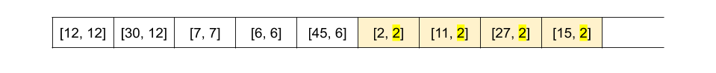

Turns out we don't—we could instead have two Stackss inside our MinStack. The main Stack should keep track of the order numbers arrived (a standard Stack), and the second Stack should keep track of the current minimum. We'll call this second Stack the "min-tracker" Stack for clarity.

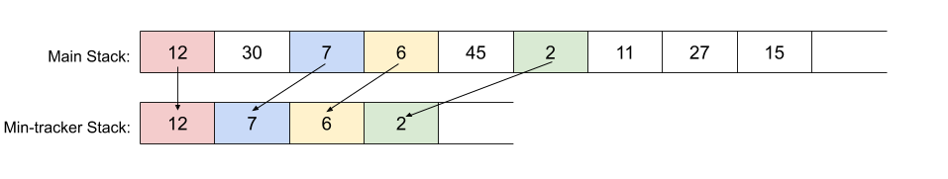

The push(...) method for this implementation of MinStack is straightforward. Items should always be pushed onto the main Stack, but they should only be pushed onto the min-tracker Stack *if they are smaller than the current top of it*. Well, that's *mostly* correct. There's one potential pitfall here that we'll look at soon.

MinStack's two getter methods, top(...) and getMin(...) are also straightforward with this approach. top(...) returns (but doesn't remove) the top value of the main Stack, whereas getMin(...) returns (but doesn't remove) the top of the min-tracker Stack.

This leaves us still needing to implement MinStack's pop(...) method. The value we actually need to pop is always on the top of the main underlying Stack. However, if we simply popped it from there, the min-tracker Stack would become incorrect once its top value had been removed from the main Stack.

A logical solution would be to do the following additional check and modification to the min-tracker Stack when MinStack's pop(...) method is called.

If top of main_stack == top of min_tracker_stack:

min_tracker_stack.pop()

This way, the new minimum would now be the top of the min-tracker Stack. If you're confused about why this is, think back to the previous approach, and remember when the minimum changed.

Here is an animation showing the algorithm so far.

As hinted to above though, there's a potential pitfall with the implementation of MinStack's push(...) method. Consider this situation.

While 6 was already at the top of the min-tracker Stack, we pushed another 6 onto the MinStack. Because this new 6 was equal to the current minimum, it didn't change what the current minimum was, and therefore wasn't pushed. At first, this worked okay.

The problem occurred though when we started calling pop(...) on MinStack. When the most recent 6 was pop'ed, the condition for popping the min-tracker Stack too was triggered (i.e. that both internal stacks have the same top). This isn't what we wanted though—it was the earlier 6 that triggered the push(...) onto the min-tracker Stack, not the latter one! The 6 should have been left alone with that first pop(...).

The way we can solve this is a small modification to the MinStack's push(...) method. Instead of only pushing numbers to the min-tracker Stack if they are *less than* the current minimum, we should push them if they are *less than or equal to* it. While this means that some duplicates are added to the min-tracker Stack, the bug will no longer occur. Here is another animation with the same test case as above, but the bug fixed.

// written by @jamesernator (James Browning)

function last(arr) {

return arr[arr.length - 1];

}

class MinStack {

_stack = [];

_minStack = [];

push(x) {

this._stack.push(x);

if (this._minStack.length === 0 || x <= last(this._minStack)) {

this._minStack.push(x);

}

}

pop() {

if (last(this._minStack) === last(this._stack)) {

this._minStack.pop();

}

this._stack.pop();

}

top() {

return last(this._stack);

}

getMin() {

return last(this._minStack);

}

}

**Complexity Analysis**

Let n*n* be the total number of operations performed.

* Time Complexity : O(1)*O*(1) for all operations.

Same as above. All our modifications are still O(1)*O*(1).

* Space Complexity : O(n)*O*(*n*).

Same as above.

Approach 3: Improved Two Stacks

**Intuition**

In the above approach, we pushed a new number onto the min-tracker Stack if, and only if, it was *less than or equal to* the current minimum.

One downside of this solution is that if the *same number* is pushed repeatedly onto MinStack, and that number also happens to be the current minimum, there'll be a lot of needless repetition on the min-tracker Stack. Recall that we put this repetition in to prevent a bug from occurring (refer to Approach 2).

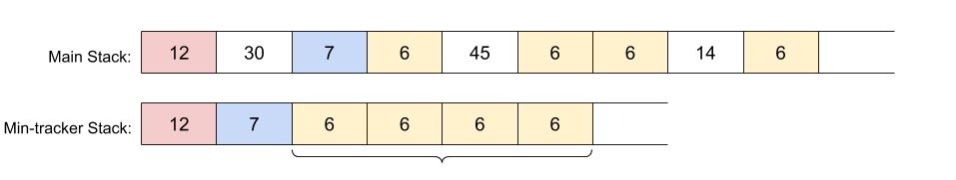

An improvement is to put *pairs* onto the min-tracker Stack. The first value of the pair would be the same as before, and the second value would be how many times that minimum was repeated. For example, this is how the min-tracker Stack for the example just above would appear.

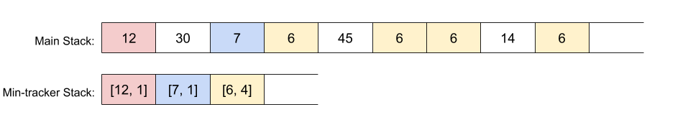

The push(...) and pop(...) operations of MinStack need to be slightly modified to work with the new representation.

**Algorithm**

// written by @jamesernator (James Browning)

function last(arr) {

return arr[arr.length - 1];

}

class MinStack {

_stack = [];

_minStack = [];

push(x) {

// We always put the number onto the main stack.

this._stack.push(x);

// If the min stack is empty, or this number is smaller

// than the top of the min stack, put it on with a count of 1.

if (this._minStack.length === 0 || x < last(this._minStack)[0]) {

this._minStack.push([x, 1]);

}

// Else if this number is equal to what's currently at the top

// of the min stack, then increment the count at the top by 1.

else if (x === last(this._minStack)[0]) {

last(this._minStack)[1]++;

}

}

pop() {

// If the top of min stack is the same as the top of stack

// then we need to decrement the count at the top by 1.

if (last(this._minStack)[0] === last(this._stack)) {

last(this._minStack)[1]--;

}

// If the count at the top of min stack is now 0, then remove

// that value as we're done with it.

if (last(this._minStack)[1] === 0) {

this._minStack.pop();

}

// And like before, pop the top of the main stack.

this._stack.pop();

}

top() {

return last(this._stack);

}

getMin() {

return last(this._minStack)[0];

}

}

**Complexity Analysis**

Let n*n* be the total number of operations performed.

* Time Complexity : O(1)*O*(1) for all operations.

Same as above.

* Space Complexity : O(n)*O*(*n*).

Same as above.